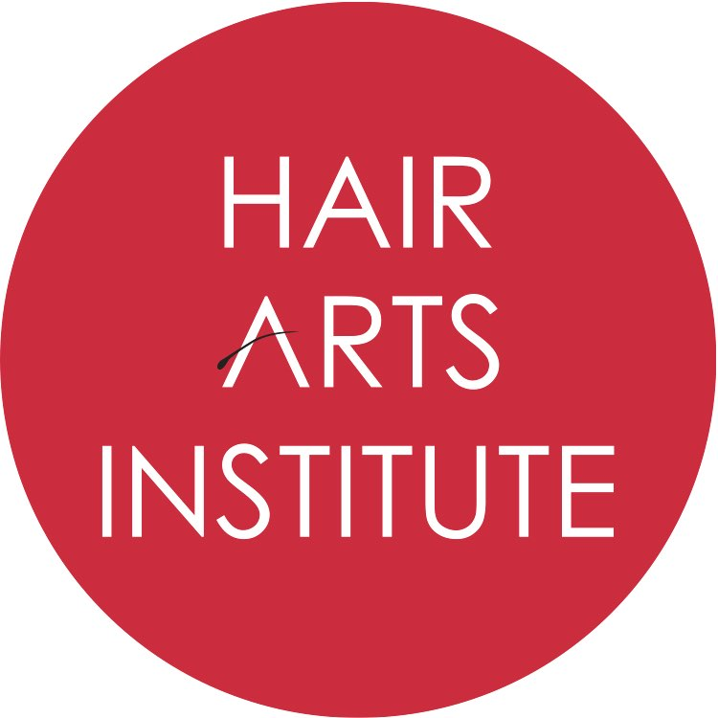

_______________________
Annual Disclosures
Voter Registration, Financial Aid, Drug Free Workplace, Family Education Rights and Privacy Act
July 27, 2023
Dear Enrolled Student and/or Staff Member,
Each year, Hair Arts Institute (referenced from this point as “HAI”) will post an annual notice to enrolled students and staff members.
This notice includes disclosures, as well as relevant consumer information.

Below is a brief description of the notice, as well as an electronic address where they are posted. If you would like to obtain a paper copy of any reports, please email info@hairartsinstitute.com or call (405)286-2600 with the title of the report/disclosure you would like to request. The Annual Security Report will be emailed separately.

Voter Registration: Students can visit their local post office to obtain a Voter Registration form and necessary requirements outlined by their state or for a downloadable version of the form visit the U.S. Election Assistance Commission at https://www.eac.gov/voters/register-and-vote-in-your-state/. State voter registration information is also available at: https://okvoterportal.okelections.us

Financial Aid Availability Information: This notice summarizes the availability of Financial Aid, summary of the Federal Pell Grants, summary of the William D. Ford Federal Direct Loan borrowers, loan repayment obligation and repayment options, as well as Borrower’s Rights, Borrower’s responsibility, Verification Process, Counseling, Federal Student Financial Aid Penalties for Drug Law Violations, and other related information.

All Campus catalog: www.hairartsinstitute.com/disclosures

Federal Student Aid Resource: https://studentaid.gov/

Drug Free Workplace, Drug and Alcohol Abuse Prevention: The Drug and Alcohol Policy and Prevention was reviewed this year, as part of a biennial review. It is referenced in the student catalog and in the Consumer brochure. The link to the catalog, consumer brochure and the full policy was provided to prospective students prior to enrollment. All materials may be accessed here: www.hairartsinstitute.com/disclosures
Family Educational Rights and Privacy Act: FERPA is the Family Educational Rights and Privacy Act which protects the privacy of student education records. HAI abides by that law and its policy is outlined in the catalog, which is distributed to prospective students prior to enrollment. For a copy of the most recent catalog, you can access it here: www.hairartsinstitute.com/disclosures

If you should have any questions, please reach out to us at info@hairartsinstitute.com or by phone, (405) 286-2600.
Hair Arts Institute

